**Investigating the Mechanisms Responsible for Anomalously High Electron**

**Temperature in Narrow-Line AGN**

Sam Jenkins

Elon University

Anomalously high electron temperatures have been observed in AGN gas clouds for more than 35 years, but to date these temperatures lack a robust explanation. Previously, numerous combinations of physical conditions have been explored, but none have proven sufficient to create the observed [O III] emission ratios indicative of high electron temperatures. Shock heating is often regarded as a possible explanation, but with the high OIII temperatures that accompany shocks, strong neutral line emission characteristic of LINERs results, which only explains a small subset of AGN. We aim to find a solution to this “temperature problem” for high temperature photoionized galaxies. Using spectroscopy from the Sloan Digital Sky Survey (SDSS) and the photoionization code called CLOUDY, we investigate high electron temperature gas clouds in the narrow line region of active galactic nuclei (AGN). Using CLOUDY simulations, we are able to examine combinations of physical parameters within gas clouds, such as hydrogen density, metallicity, ionization parameter and grain abundance, to search for conditions that would replicate the electron temperatures we see in the SDSS. We use OIII emission line ratios to determine the electron temperature in the clouds, and find that our highest temperature data points reach up to (find Te, still need help with this). Using emission line diagnostic diagrams, we discover how variance in each physical characteristics affects gas cloud temperatures. We find that hydrogen density and ionization parameter variation, as well as metallicity and ionization parameter variation, cannot account for the highest observed temperatures but can account for the AGN showing *Te* < 1.54 x 104 K. Our most successful simulations contain 5 times the grain abundance of the Orion nebula, and Z < 1.4 *Z*☉ , which can reproduce the electron temperature in some of our high temperature observations with *Te* > 1.54 x 104 K. These models match our high temperature data quite well for high values of ionization and low metallicity, but miss the low ionization, high metallicity, high temperature AGN.

**1. Introduction**

Nebular clouds in star forming regions and active galactic nuclei (AGN) typically show electron temperatures around *Te* = 1.5x104 K in the OIII emitting region (Osterbrock & Ferland 2006). However, anomalously high values *Te* > 1.54x104 K have been noticed in surveys for decades without a thorough explanation for the physical mechanism responsible for creating such conditions in narrow line emitting AGN (Shuder & Osterbrock 1981, Komossa & Schulz 1997, Zhang et al. 2013, Richardson et al. 2014). While more recent work has started to address the topic head on, signatures of high *Te* have been present in small spectroscopic samples of AGN.

Shuder & Osterbrock (1981) showed *Te* > 1.7x104 K in 5 of the 12 galaxies for which they measure electron temperature, but do not include any models in their work, which left the question of why such high *Te* is observed in some galaxies. Komossa & Schulz (1997) investigated a larger data set, including 37 galaxies in their study. They also include models in their analysis, which includes assuming various properties of the cloud to predict emission lines, through which they can predict conditions within the cloud. Values are assumed for the spectral energy distribution (SED) (e.g accretion disk blackbody temperature) and a luminosity of hydrogen ionizing photons emitted by the galactic nucleus. Along with cloud distance from the emission source and hydrogen density (nH), these values can be used to calculate the ionization parameter *U*. The wide range of parameters varied led to a range of log *U* between -6.58 and +0.42. Komossa & Schulz (1997) also varied the metallicity of the cloud, *Z*, and stop their models once the hydrogen column density dropped below a pre-determined value. These input parameters were used in a photoionization code called Cloudy c84.03 (Ferland 1993). Cloudy then outputs emission line strengths for any requested lines, and these line strengths are used to determine conditions within the cloud. This approach proves to be common when modeling the NLR. They mention proposed explanations for the temperature problem, and conclude that the only explanation that can account for the emission spectrums as a whole would be low metallicity. Metals in the gas provide a cooling effect, and therefore decreasing electron temperatures.

Dopita & Sutherland (1995) also model high temperature galaxies, but they employ shocks as an excitation mechanism to reach those high temperatures and solve the temperature problem for a small subset of objects. To model these shocks, they varied magnetic field strength from 2 < B/n1/2 < 4 μG, and shock velocity from 150 – 500 kms-1. They derive interesting results from their models, including an inverse relationship between shock velocity and electron temperature. They use a diagnostic diagram that shows log[O III] λ5007/Hβ vs. log [O I] λ6300/Hα, which is particularly sensitive to shock excitation (Kewley et al. 2006). This plot neatly separates star-forming, AGN and LINER galaxies and overlaying their shock models on this diagram reveals relevant information. Though the lower velocity shocks produce high electron temperature, in fact up to 6.5x104K, these models fall inside the LINER category. Though this shock heating provides high electron temperatures, nearly all of these shock heated galaxies led to a LINER (low ionization narrow emission line regions) classification due to strong neutral line emission. Many LINERs are thought to be shock heated AGN, but these results do not provide an explanation for the high temperature photoionized AGN classified as Seyferts. In order develop a complete solution, the temperature problem also requires a solution for photoionized AGN, so this group’s results leave the question partially unanswered.

Groves, Dopita & Sutherland (2004) incorporated dust in their models in an attempt to increase electron temperature due to photoelectric heating, which at the time was a new approach. This group also used the MAPPINGS III code instead of CLOUDY to do their models. Notably, they included a narrower range of parameters than Dopita & Sutherland (1995) by varying nH from 102 – 104 cm-3, 0.25 Z☉ < Z☉ < 4.0 Z☉, and power law index α from -1.2 to -2.0 for the SED. The ionization parameter *U* was varied from -4.0 < log *U* < 0.0 in intervals of -0.3, -0.6, and -1.0 dex, and they varied grain content proportional to metallicity, though they claimed this is a gross over simplification and cannot be justified, but it is the simplest way to model the grain content. Their models showed higher electron temperatures with higher grain content, and they mentioned that including grains in their models helped alleviate some of the temperature problem, though more work is needed.

Richardson et al. (2014) investigated the effects of density, ionization, grains and metallicity on AGN gas, and referred to many of the studies mentioned above. They mentioned that Komossa & Schulz (1997) drastically overestimates [O I] emission with high density values, which likely means that high density regions do not exist. Instead, increasing density increases [O I] emission but does not affect Hα or Hβ emission, so different emission line ratios are observed. As we mentioned, Komossa & Schulz (1997) also touched on the cooling effect of metals in the gas, explaining that increased metallicity can cool the gas and decrease electron temperatures. However, it may be the case that AGN with low metallicity values are rare, meaning that may not be a sufficient explanation for the high electron temperatures seen in some samples. Grains were shown to increase electron temperatures through photoelectric heating and can reproduce high ionization AGN Te but miss the mark with the highest ionization AGN in the sample. Interestingly, they also included a model with cosmic rays, which would provide another excitation mechanism on top of photoionization, but their model shows negligible effects on Te.

Also notable is this group’s approach to modeling. They used a local optimally emitting cloud (LOC) model, which treats the NLR as a sum of many individual gas clouds distributed around the central source. Individual clouds were modeled using Cloudy c10.0. These models were stopped once Te exceeded 100,000K or fell below 4000K, as temperatures above that range contribute primarily to X-Ray emission and temperatures any lower contribute primarily to IR emission. They then integrated over radial distance and density distributions to account for the NLR as a whole. This approach is certainly different from the models from the previously mentioned groups, but still does not provide a solution to the temperature problem. However, this approach can account for the fact that we observe the sum of all sections of the NLR and simulating this as numerous individual clouds can more accurately represent that. For example, if we observe high electron temperature and low metallicity from an NLR, it is likely that the entire NLR is not homogenously high temperature and low metallicity, but there could be pockets of low temperature and high metallicity, and this method can simulate that variation.

Zhang Liang and Hammer (2013) mentioned that the temperature problem is still unsolved. They explained though shock models have been investigated, but it is generally believed that photoionization is the dominant excitation mechanism in most AGN. In addition, shock models require shocks that permeate throughout the NLR, but this proves inconsistent because shock signatures are often not observed. Indeed, the most successful shock models (Dopita & Sutherland 1997) show LINER-like emission line ratios rather than emission line ratio typical for AGN.

They also explained that previous observations have shown that NLR clouds are likely to be dusty in nature, supporting the evidence for higher grain content in these clouds. Their most successful models were dusty, radiation-pressure dominated photoionized AGN models that included *n*H = 100 cm -3 and a power law index of -1.4. In addition, they included a discussion of the effects of low metallicity, including decreased metallicity increasing electron temperatures and decreasing the number of available high-energy photons to ionize hydrogen. Most importantly, they concluded that “some strong [OIII] λ4363 emission Seyfert 2 galaxies with Te >15000 K can be fitted with dusty AGN model grids at low metallicity (i.e. Z/ZO ~ 1.0).” This conclusion shows the combination of dust and low metallicity is capable of producing strong [OIII] λ4363 emission in AGN.

Using these previous studies, we can determine a new approach to solving the temperature problem. For our investigation, we will use a sample of galaxies taken from the Sloan Digital Sky Survey (SDSS), and filter through this data using a SQL query. We use high S/N ratios for the essential emission lines. We do not include any LINERs in our data set because we are focusing on high temperature photoionized AGN, which also means we do not investigate shocks as a possible excitation mechanism. We separate galaxies by type so we can focus on AGN. Using [OIII] λ4363, we categorize our galaxies by temperature so we can focus on the high electron temperature outliers in the data set.

We use this background data set to compare to our models, which are done in CLOUDY13.03. This newer edition of CLOUDY compared to the previously mentioned studies contains more advanced code and has updated atomic data, making our models more accurate and detailed. Our overall approach to the models is similar to that of Dopita & Sutherland (1995). We will assume certain characteristics of the cloud, including *n*H, *U*, and *Z*. However, our model will also vary grain content to explore the impact on electron temperature via photoelectric heating. Another unique aspect of our study is that it will focus on a robust exploration of the temperature problem in photoionized AGN. Numerous studies have touched on the fact that this problem exists and given attempts at solving it, but our study is unique in that it will focus specifically on the temperature problem with the sole goal of finding a solution.

**3. Modeling the Narrow Line Region**

*3.1 The Central Source*

We conduct our modeling with CLOUDY version 13.03 (Ferland et al. 2013). We set cosmic ray background values according to Indriolo et al. (2007). We set the shape of the SED according to the following,

:

where *T*BB is the blackbody temperature of the central accretion disk, which we set to 2x105 K, αuv is the low energy slope of the big blue bump continuum, αx is the high energy slope of the continuum, and αox is the ratio of x-ray to UV peak values in the continuum. We take these three values from an average of values in Grupe et al. 2010, which are αuv = -0.57, αx = -1.63 and αox = -1.42. *kT*IR, which is the location of the infrared exponential cutoff in the Big Blue Bump component, is set to .01Ryd, and *a* is a normalization. We vary the ionization parameter, which is equal to the following relation:

where, U is the ionization parameter, Φ(H) is the hydrogen-ionizing photon flux, and n(H) is the total hydrogen density. Our models vary log *U* from -3.5 to -0.5 in 0.5 steps.

*3.2 The Cloud*

We set our gas abundances according to Grevesse et al. (2010). Many of our models involving varying values of *Z*☉ , from 0.5 *Z*☉ to 2 *Z*☉ in 0.3 linear steps. We also must manually determine the value for helium and nitrogen when we change our metallicity, because they do not scale linearly with other elements (Baldwin et al. 1991). We do this using ΔY = ΔZ (Baldwin et al. 1991) , where Y is the He mass fraction, and [N/H] ~ Z2. For other elements, [x/H] ~ Z where x is a given element (Hamman et al. 2002). We use the metals deplete command, which accounts for the loss in gaseous metals coming from the formation of grains in the cloud using results from Jenkins (1987) and Cowie & Songaila (1986). We maintain constant pressure throughout the cloud and stop our model when *n*e/*n*H = 0.01. Stopping our models at a designated electron density fraction allows this stopping condition to scale to all clouds and helps us accurately model O I emission, as opposed to a set depth that would remain constant for clouds of all sizes. We also vary grain content in the cloud, from 0.5 to 5 times Orion nebula values in 0.5 linear steps. We use the grains Orion command in CLOUDY to specify graphite and silicate grain composition, as well as a size distribution consistent with those along the line of sight of the Trapezium stars in the Orion nebula (Baldwin et al. 1991). Finally, we also vary log(nH) [cm-3] from 1 to 4 in 0.5 steps.

**4 Diagnostics**

To evaluate our models, we use diagnostic diagrams to plot them on top of the observation data mentioned previously. We use numerous plots to analyze our models, but one of the most important is the BPT Diagram (Baldwin, Phillips, and Terelvich 1981), which is a plot of log[OIII]5007/Hβ vs. log[NII]6584/Hα. The diagram separates star forming galaxies, AGN and composite galaxies, which helps us know what kinds of galaxies are in our data set. To further confirm, we use calculations from Kewley et al. 2006 that allow us to shape code our data based on galaxy type. From these calculations we found that our data set included 102 ambiguous objects, 145 star-forming galaxies, 70 AGN, 3 composites and 0 LINERs. Figure 1a shows our observational data plotted on a BPT diagram using the shape code from Kewley et al. 2006. Using a relation between [O III] λ4363, [O III] λ5007 and [O III] λ4959, coupled with electron densities, we can derive *Te* from a given spectrum (Osterbrock & Ferland 2006). Using this method, we color code our data based on *Te* which neatly separates our data on a plot of log[O III]5007/4363 vs. log[N II] 6584/Hα (Figure 1b). We categorize our data into low (*Te* < 1.17*104 K), mid (1.17*104 K < *Te* < 1.54*104 K), and high (*Te* > 1.54*104 K) temperatures. Overlaying our models on top of each of these diagrams allows us to determine whether our models are accurately reproducing the physical conditions present in our data set.

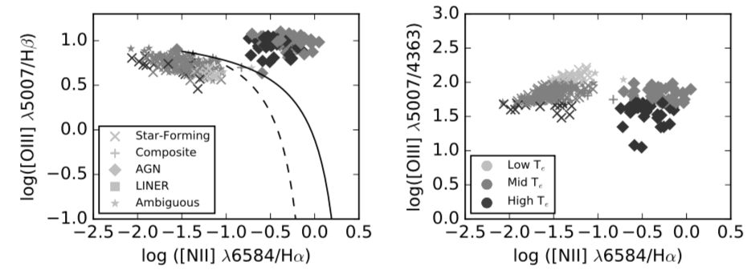

Figure 1: BPT Diagram and Temperature Diagnostic Diagram with observational data and without models, including color and shape code to separate by temperature and type.

*4.1 Ionization Parameter and Hydrogen Density*

We first investigate the effects of *n*H and *U* variation on the temperature sensitive [O III] λ5007 / λ4363. High *n*H can show [O III] emission consistent with high *Te* from collisional de-excitation. When electrons get excited by incident photons, they can de-excite by colliding with a free electron before the excited electron spontaneously de-excites and emits a photon. The free electron carries away the energy of the incident photon and the excited electron returns to its initial state. This effect disproportionally affects OIII λ5007, meaning we observe a lower ratio OIII ratio, giving a false high temperature reading. Increased U means increased ionizing photon flux, which can correlate to higher *Te* because this flux removes electrons and raises the temperature of the electron gas. To investigate this, we run CLOUDY models with log U ranging from -3.5 to -0.5 in 0.5 steps, and log(nH) [cm-3]ranging from 1 to 4 in 0.5 steps. We set Z = 1.2 *Z*☉ , which fell in the middle of our AGN in our metallicity diagnostic diagram (see Figure 3c). Our diagnostic diagrams show that these values cannot produce the anomalously high *Te* we see in our data set. Our highest temperature models, which contained log(nH) = 1.0 and log(U) = -0.5, barely reached 1.54x104 K, which is the low temperature boundary for what we consider to be “high temperature”. Our models using log(U) < -1.0 and all nH values match about half of our high temperature AGN on our BPT Diagram and 90% of all AGN on our density diagnostic, but the temperature diagnostic shows that we are far from the highest temperature galaxies in our data set.

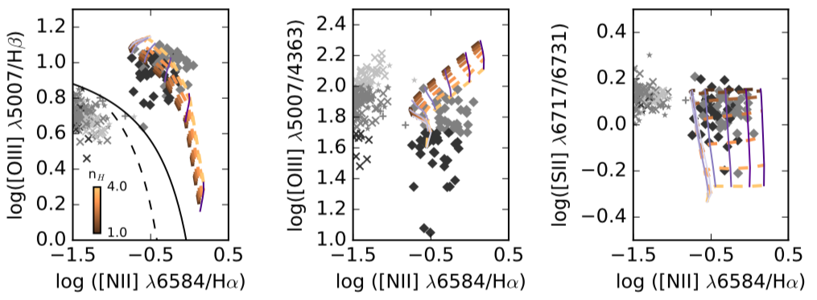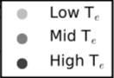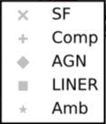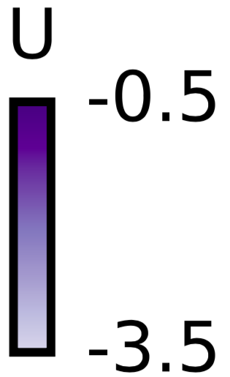

Figure 2: BPT Diagram, Temperature Diagnostic diagram and nH diagnostic diagram with a model featuring 1 < nH < 4 and -3.5 < log U < -0.5. Data is categorized into low (*Te* < 1.17 x 104 K), mid (1.17 x 104 K < *Te* < 1.54 x 104 K), and high (*Te* > 1.54 x 104 K) temperatures, and galaxy types are determined according to Kewley et al. 2006.

*4.2 Metallicity and Ionization Parameter*

We also investigate the effects of variation in Z and U. Metals have a cooling effect on the gas, because they collisionally excite but then radiate away that energy through photon emission, causing the *Te* to decrease. We ran models with *Z* ranging from 0.5 *Z*☉ to 2 *Z*☉ in 0.3 linear steps, and U from log(-3.5) to log(-0.5) in 0.5 steps. We set log(nH) [cm-3] = 2.4 because this value represents the approximate mean value of hydrogen density of AGN in our nH vs. U models (see Figure 2c). Plotting these models reveals that we match nearly all of our high temperature AGN on the BPT Diagram and our metallicity diagnostic. However, the highest temperature models, which contained *Z* = 0.5 *Z*☉ and log(U) = -3.5, only reach approximately 1.54x104 K, meaning we are still far from the highest temperature AGN.

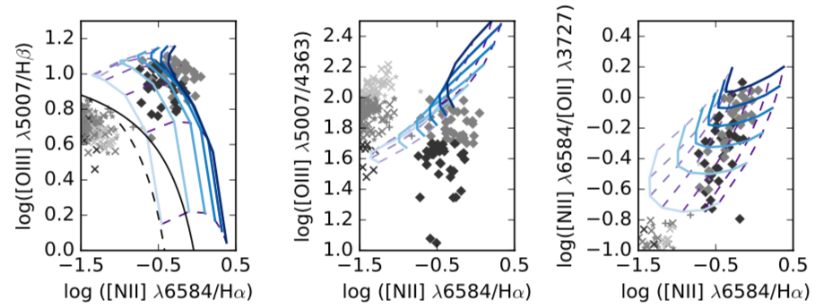

Figure 3: BPT Diagram and Temperature Diagnostic diagram with models featuring 0.5 < Z < 5 and -3.5 < log U < -0.5. The observational data points follow the same classification and temperature criteria as Fig. 2.

*4.3 Metallicity and Grains*

Our highest *Te* results have come from Z and grain abundance models. We study grain abundance because of photoelectric heating from grains, meaning photons hitting these grains can eject an electron from the grain into the electron cloud, increasing its temperature. We varied Z from 0.5 *Z*☉ to 2 *Z*☉ in 0.3 linear steps, and grains from 0.5 to 5 times Orion nebula values (Baldwin et al. 1991) in 0.5 linear steps. We set log(U) = -1.5 because that value fell in the middle of our AGN in the BPT Diagram of our nH and U models. The BPT Diagram shows that with these models, we match about half of our high temperature AGN, and our metallicity plot shows our models matching just over half. However, our temperature diagnostic shows that we reach the middle of our high temperature group of AGN, meaning these models produce far higher *Te* than any of our previous attempts. As we expect, these highest temperature models feature 5.0 grain abundance and 0.5 *Z*☉. This result tells us that higher grain content provides significantly higher *Te* than solar values. Though these models produce the highest temperatures, they still cannot match the highest temperatures we observe in the data set. This means there must be another mechanism heating the gas clouds, because varying the physical parameters alone cannot account for the observed temperatures. [Thoughts?]

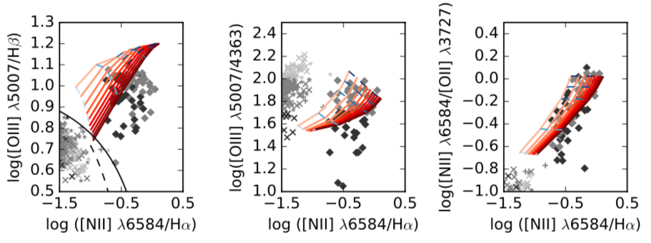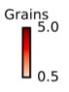

Figure 4: BPT Diagram and Temperature Diagnostic diagram with models featuring 0.5 < Z < 5 and 0.5 < grains < 5. The observational data points follow the same classification and temperature criteria as Fig. 2. [There is a metallicity grid point missing. I know that you had this same problem twice, during SURE and making your AAS poster. Perhaps you’re using an outdated script or have in your notes how to correct it?]

**5. Implications and Future Work**

These simulations have given us informative results, including what parameters cannot account for the high *Te* we observe. We have shown that a combination of nH and U variation is unable to reproduce the anomalously high *Te* we see in the data, but these models can match the low temperature observations. The temperature diagnostic diagram reveals that these models struggle to reach many of the mid temperature galaxies, particularly for high values of ionization parameter. In our Z and U models, we were able to match almost all of our AGN on the BPT and metallicity diagnostic diagrams, but the temperature diagnostic revealed that we missed the mark on all the high temperature and many of the mid temperature AGN. These models show a lower ionization sensitive NII/Hα ratio than most of the data points on the temperature diagnostic (meaning…? Also that is predominantly U sensitive, correct? N II/Ha is sensitive to ionization parameter and Z, but I don’t follow your sentence so we need to discuss it) [Just that the model is left of much of the data at the highest temps] Our Z vs. grain abundance models proved the most successful, matching almost half of the high temperature data points on our temperature diagnostic, and the majority of our AGN on the metallicity sensitive NII/OII diagnostic [Is this for low metallicity and high grain abundance? Yes]. Our BPT diagram reveals that these models also show a lower NII/Hα ratio than most of our data (I’m not sure about what the last sentence means) Again just that the models are to the left of a lot of the data on the BPT, not sure what the correct way to word this would be.

[If my statement about low metallicity and high grain abundance is correct, we need to think about how this could actually occur. Usually, less metals would mean less grains, so why would the results indicate the opposite scenario??? Doesn’t the metal in the grain have to come from the metal in the gas? Meaning to form the grains you need to “use up” some of the metal in the gas? Or am I wrong there]

[[[Turbulence shows interesting results because it gives high Te, but puts the grids in the LINER category. This could be a result of turbulence being present in some clouds of an AGN NLR and causing high [OIII]4363 observations and LINER characteristics, though the turbulence doesn’t permeate through the entire NLR.]]]]

**References**

Albareti et al., 2015, arXiv: 1501.00963

Baldwin, J., et al. 1991, ApJ, 374, 580-609

Baldwin, J., Phillips, M., Terlevich, R., 1981, PASP, 93, 5-19

Cowie, L.L., Songaila, A., 1986, ARA&A, 24, 499-535

Ferland et al., 2013, arXiv: 1302.4485

Ferland, G., Netzer, H., 1983, ApJ, 264, 105-113

Hamann, F., Korista, K.T., Ferland, G.J., Warner, C., Baldwin, J., 2002, ApJ, 564, 2, 592-603

Grevesse, N., Asplund, M., Sauval, A.J., Scott, P., 2010, Ap&SS, 328, 1-2, 179-183

Grupe, D., Komossa, S., Leighly, K., Page, K., 2010, ApJ, 187, 1

Kewley, L., Groves, B., Kauffmann, G., Heckman, T., 2006, MNRAS, 372, 961

Indriolo, N., Geballe, T.R., Oka, T., McCall, B.J., 2007, ApJ, 671, 2, 1736-1747

Jenkins, E. B., 1987, ASSL, 533-559

Komossa, S., Schulz, H., 1997, Astronomy and Astrophysics, 323, 31-46

Osterbrock, D., Ferland, G., 2006, *Astrophysics of Gaseous Nebulae and Active Galactic Nuclei*

Richardson, C., Allen, J., Baldwin, J., Hewett, P., Ferland, G., 2014, MNRAS, 437, 2376

Zhang, Z.T., Liang, Y.C., Hammer, F., 2013, MNRAS, 430, 2605-2621